附件1

信息报送二维码

类型 | 链接 | 二维码
活动信息报送链接 | https://docs.qq.com/form/page/DT1JQbWloUFNLQ1hO?_w_tencentdocx_form=1 | 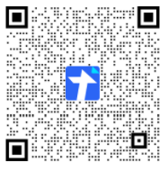
线上学习资源报送链接 | https://docs.qq.com/form/page/DT1FJQVB3UFd5bkV1?_w_tencentdocx_form=1 | 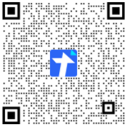
地市和院校联系人报送链接链接 | https://docs.qq.com/form/page/DT2xTVUFhQVZRblNn?_w_tencentdocx_form=1 | 